After synchronysing decks from desktop app to ankiweb, it shows like below picture

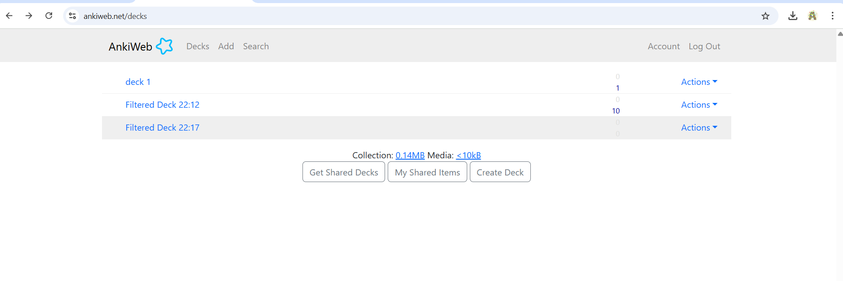

After choosing deck from list it shows question like this

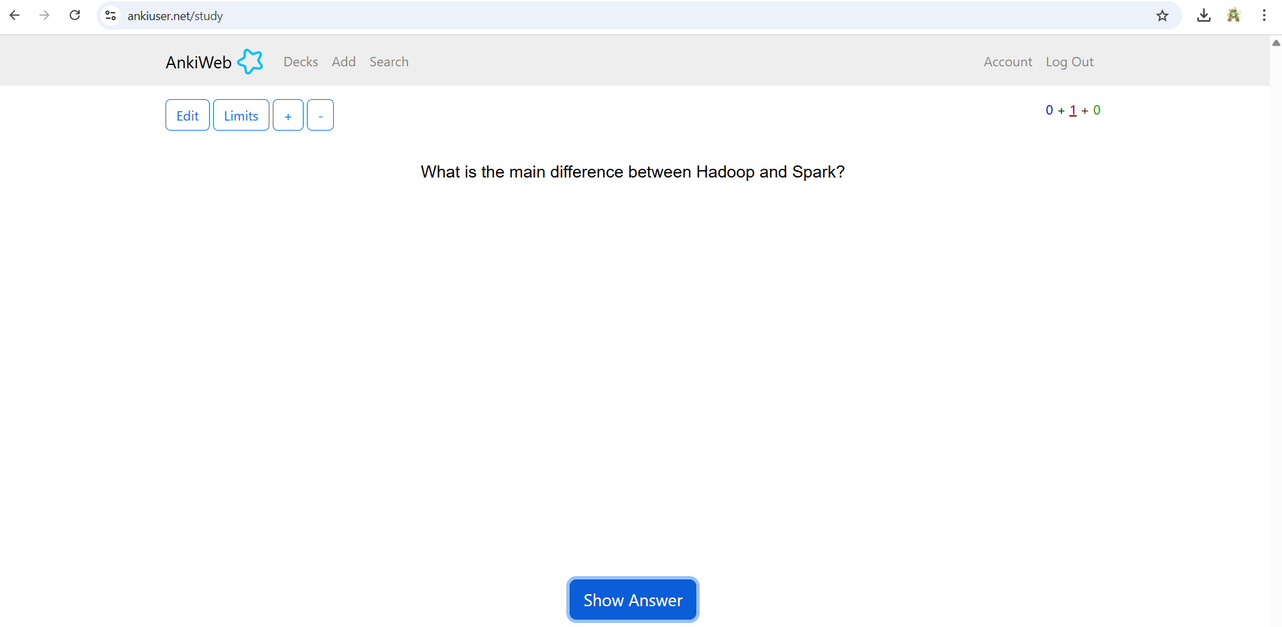

Then after clicking on answer it shows answer along with question

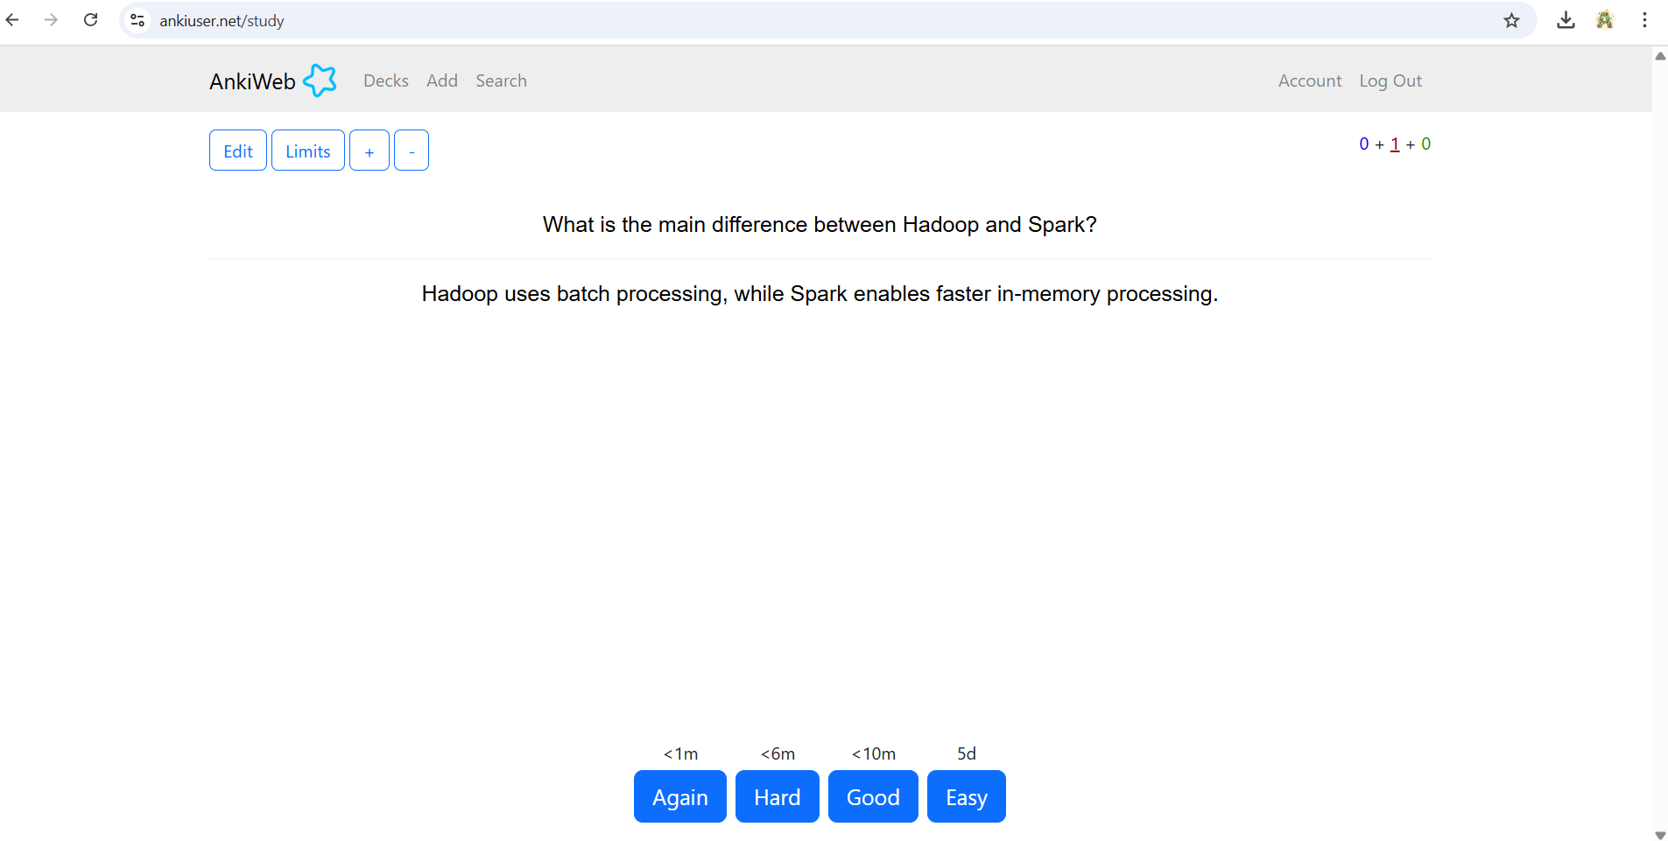

Then clicking on again button it shows the message shown below

